**Kol Simcha Torah Gazette**

**For parsha re’eh 5785**

Volume 9 Issue 47 (Whole #461) 29 Menachem Av 5785/ August 30, 2025

**Printed L’illuy nishmas Nechama bas R’ Noach, a”h**

For a free subscription, please forward your request to [***keren18@juno.com***](mailto:keren18@juno.com)

***Past emails can be found on the website ShabbosStories.com under Brooklyn Torah Gazette***

**Kabbalah Red String Bracelets: Are They Jewish?**

**Evil Eye Jewelry and Kabbalah Bracelets**

**By** [**Yehuda Shurpin**](https://www.chabad.org/search/keyword_cdo/kid/15169/jewish/Shurpin-Yehuda.htm)

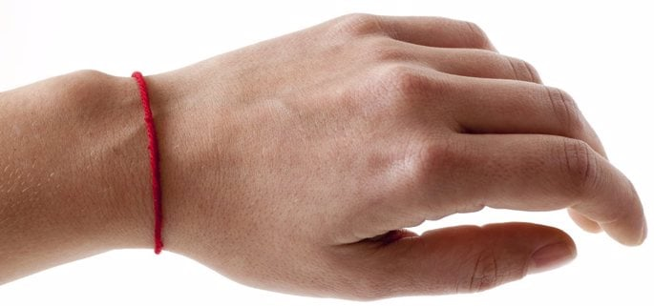

Some people wear red strings around their wrists to ward off an *ayin hara* (evil eye). Does this have a source in Judaism?

As I discussed in [What Is the Meaning of the Evil Eye?](https://www.chabad.org/library/article_cdo/aid/166909/jewish/What-Is-the-Meaning-of-the-Evil-Eye.htm), there are indeed Jewish sources for the concept of an [*ayin hara*](https://www.chabad.org/library/article_cdo/aid/166909/jewish/What-Is-the-Meaning-of-the-Evil-Eye.htm) (evil eye). However, one would be hard-pressed to find a reputable Jewish source (kabbalistic or otherwise) for wearing a red string as a means of warding off the evil eye.

**The Color Red**

Rabbi Chaim Elazar Spira of Munkács, known as the Minchat Elazar (b. 1868), records a custom to carry a red cloth or similar red item to ward off *ayin hara.*He explains that different colors represent different Divine attributes, and red represents *gevurah* (stringency and judgment), which is sometimes linked with negative spiritual energy. Thus, by having the red item, one can overcome an [*ayin*](https://www.chabad.org/library/article_cdo/aid/1074094/jewish/Something-About-Nothing.htm)*hara*, beating evil at its own game.[1](javascript:doFootnote('1a3937562');) Note that he makes no mention of bracelets or strings, and there’s good reason for that.

**Pagan Ways**

There are certain foreign, superstitious practices that, although not idol worship in the strict sense, are nevertheless forbidden due to their pagan origins. These are referred to as *darkei Amori* (“the ways of the Amorites”). In a list of such practices found in the Tosefta (an extra-Mishnaic work), “tying a red string on one's finger,” is listed.[2](javascript:doFootnote('2a3937562');) This implies that wearing a red string falls under the rubric of a forbidden pagan practice.

Now, there are some who explain that despite the Tosefta, the red string is not a violation of *darkei Amori*(see footnote[3](javascript:doFootnote('3a3937562');)).[4](javascript:doFootnote('4a3937562');) Others, however, maintain that it is indeed problematic*.*[5](javascript:doFootnote('5a3937562');)

It is said that the Lubavitcher Rebbe, Rabbi Menachem M. Schneerson, of righteous memory, was once asked about this in a private audience. He was initially hesitant to express his view on the red string bracelets, but then cautioned against them due to the issue of *darkei Amori*.[6](javascript:doFootnote('6a3937562');)

**Red or Blue?**

On the topic of which colors can ward off the evil eye, I would venture to say that blue, or more specifically *[techelet](https://www.chabad.org/library/article_cdo/aid/530127/jewish/Tekhelet-The-Mystery-of-the-Long-Lost-Biblical-Blue-Thread.htm" \o "Tekhelet: The Mystery of the Long-Lost Biblical Blue Thread)* (indigo), is a much better candidate. The Zohar states that if someone looks at you with an evil eye, look at something the color of *techelet*and the evil eye will have no power over you.[7](javascript:doFootnote('7a3937562');)

This is perhaps connected to the Talmudic teaching that *[techelet](https://www.chabad.org/library/article_cdo/aid/6514144/jewish/Why-Do-Most-Jews-Not-Wear-Blue-Tzitzit.htm" \o "Why Do Most Jews Not Wear Blue Tzitzit?)* resembles the sea, which reflects the sky, which is reminiscent of G‑d’s “throne.”[8](javascript:doFootnote('8a3937562');)

**The True Remedy**

When discussing spiritual remedies or charms, even those with an authentic source, the Lubavitcher Rebbe would caution that not all people or situations are the same. Since these charms require very specific intention and know-how, it is unlikely for even the legitimate ones to have a serious effect.

With regard to charmers and soothsayers, the Torah enjoins us to “be wholehearted with the L‑rd, your [G‑d](https://www.chabad.org/library/article_cdo/aid/433240/jewish/God.htm).”[9](javascript:doFootnote('9a3937562');) Ultimately, connecting to G‑d through meditating on His greatness, learning His [Torah](https://www.chabad.org/library/article_cdo/aid/1426382/jewish/Torah.htm) and adding in mitzvahs is the “true and tried remedy.”[10](javascript:doFootnote('10a3937562');) There is no reason to fear an evil eye or try any of these other means of protection.

**Footnotes**

[1.](https://www.chabad.org/library/article_cdo/aid/3937562/jewish/Kabbalah-Red-String-Bracelets-Are-They-Jewish.htm" \l "footnoteRef1a3937562) Divrei Torah, Mahadura Tinyana 71.

[2.](https://www.chabad.org/library/article_cdo/aid/3937562/jewish/Kabbalah-Red-String-Bracelets-Are-They-Jewish.htm" \l "footnoteRef2a3937562) Tosefta, Shabbat, ch. 7; also quoted in Reishit Chochmah, Perek Derech Eretz.

[3.](https://www.chabad.org/library/article_cdo/aid/3937562/jewish/Kabbalah-Red-String-Bracelets-Are-They-Jewish.htm" \l "footnoteRef3a3937562) See, for example, responsa Rivivot Ephraim 8:51:3 where he explains that: a) according to one version of the Tosefta, the prohibition is limited to putting the string on a wound; b) some hold that only pagan practices codified in the Talmud itself are prohibited (see Beit Yosef, Yoreh Deah 178). Since the red string is listed in the Tosefta but not in in the Talmud, it may indicate that the final *halachah* does not view it as problematic; c) the Tosefta only mentions tying the string on the finger, but may not include wearing it as a bracelet; d) some hold that once a pagan practice is no longer in use, it becomes permissible (see Minhag Yisrael Torah, vol. 6, 179). It has been suggested that since pagans no longer wear the red strings, there may be no issue with it. However, it is very questionable whether this practice has indeed “fallen into disuse.”

[4.](https://www.chabad.org/library/article_cdo/aid/3937562/jewish/Kabbalah-Red-String-Bracelets-Are-They-Jewish.htm" \l "footnoteRef4a3937562) See, for example, responsa Rivivot Ephraim 8:51:3 and Be’er Moshe 8:36.

[5.](https://www.chabad.org/library/article_cdo/aid/3937562/jewish/Kabbalah-Red-String-Bracelets-Are-They-Jewish.htm" \l "footnoteRef5a3937562) See, for example, Darkei Teshuvah, Yoreh Deah 179:21 (quoting the Reishit Chachmah), where he specifically lists wearing a red string as *darkei Amori.*

[6.](https://www.chabad.org/library/article_cdo/aid/3937562/jewish/Kabbalah-Red-String-Bracelets-Are-They-Jewish.htm" \l "footnoteRef6a3937562) Heard from Rabbi Leibel Schapiro, dean of the Yeshivah Gedolah of Greater Miami; see account in Hitkashrut 857.

[7.](https://www.chabad.org/library/article_cdo/aid/3937562/jewish/Kabbalah-Red-String-Bracelets-Are-They-Jewish.htm" \l "footnoteRef7a3937562) Zohar 3:163b.

[8.](https://www.chabad.org/library/article_cdo/aid/3937562/jewish/Kabbalah-Red-String-Bracelets-Are-They-Jewish.htm" \l "footnoteRef8a3937562) Talmud [Sotah 17a](https://www.chabad.org/torah-texts/5452513/The-Talmud/Sotah/Chapter-2/17a" \o "Sotah 17a).

[9.](https://www.chabad.org/library/article_cdo/aid/3937562/jewish/Kabbalah-Red-String-Bracelets-Are-They-Jewish.htm" \l "footnoteRef9a3937562) [Deuteronomy 18:13](https://www.chabad.org/library/bible_cdo/aid/9982/jewish/Chapter-18.htm#v13).

[10.](https://www.chabad.org/library/article_cdo/aid/3937562/jewish/Kabbalah-Red-String-Bracelets-Are-They-Jewish.htm" \l "footnoteRef10a3937562) See Igrot Kodesh, vol. 12, p. 184, and vol. 14, p. 394.

*Reprinted from the current website of Chabad.org*

**Rav Avigdor Miller on**

**Singing During Davening**

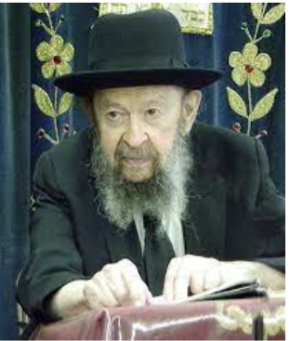

**QUESTION**: Is there a benefit to be gained by singing at certain occasions?

**ANSWER**: I want to explain something about this.

On Shabbos, it’s a mitzvah to honor the Shabbos by singing.  Even if you’re not capable, try it anyhow and learn certain tunes.  Not only does it enhance the glory of the Shabbos when people sing—it shows they appreciate the Shabbos more—it leaves an influence on the family.  Sometimes even neighbors are influenced when they hear singing at the Shabbos table of an Orthodox family nearby.

When it comes, however, to singing during the *tefillos*, that’s a different story.

I’ll tell you a little thing I noticed. When I was in Slabodka, they refrained from singing when the *shatz* was standing at the *amud*.  The *shaliach tzibur* never sang anything.  He was like talking when he recited the *tefillos*.

Now there was another yeshiva in Lithuania called Telz. And sometimes a Telzer used to visit Slabodka and when the Telzer was standing at the *amud* and leading the *davenen*, sometimes he indulged in a little bit of singing.  A little suspicion of singing. And the Slabodkers all smiled at that.  They considered it not proper to sing.

Why? Because singing is a substitute for thinking. Instead of concentrating on what you’re saying, many people are caught up in the enthusiasm of the lilting notes of the prayers—it’s poetry too—and they get accustomed to singing it and they think that that takes the place of thinking.

Prayer is for thinking.  *Tefillah* comes from the word *pillel*.  רְאֹה פָנֶיךָ לֹא פִלָּלְתִּי. Yaakov said, “I never thought to see your face.” (Bereishis 48:11). *Pillel*means to think.  *Pillel*means to meditate.  It’s a very big achievement if you learn to pray with thought.

And therefore, it’s not recommended—at least from my point of view—to sing in *tefillah*.  Many people do that and they say it helps to enhance their enthusiasm in *tefillah*. But when a person really wants to pray with meditation, it’s important to listen to what you’re saying.

It could be after you have said the word and you have gained the import of the word, the message, it could be if you repeat it now with song again, it could be it has more effect.  But it’s of utmost importance to utilize the *tefillah*for thinking in what you’re saying.



And the Rambam says, כל תפילה שאינה בכוונה אינה תפילה – *tefillah*without thought is not called *tefillah* (Hilchos Tefillah 4:15). And it’s a great pity that people spend their lives in *tefillah*—many times they even add things to the *tefillah* before and after; some say Tehillim too—but if it’s not said with thought, it’s really a pity because it’s an opportunity gone lost.

The greatness of *tefillah*develops your mind in such ways, you actually become ennobled by these great words.  *Tefillah*ennobles the mind.  Great teachings in *tefillah*.  You’d be surprised what depth, what profundity there is in the *siddur*. Only that it requires thinking, and music is not conducive to thinking. (January 1990)

*Reprinted from the current Eikev 5785 email of Torah Avigdor.*

**Hearing Does Not**

**Resemble Seeing**

**From the Teachings of the Lubavitcher Rebbe**

**Rabbi Menachem Mendel Schneerson, Zt”l**



This week's Torah portion, Re'ei, is always read at a time associated with the month of Elul, either on the Shabbat on which the month of Elul as in the present year, or on Rosh Chodesh Elul.

Re'ei begins with the verse, "Behold, I am giving before you today the blessing..." This verse refers to the fact that the blessing, and the revelation of G-dliness that accompanies it, is coming from Above. Indeed, each of the words of this verse emphasizes that approach:

Behold: Seeing implies the establishment of a deep and powerful connection. Thus, our Sages state, "hearing does not resemble seeing," and they forbid an eyewitness from acting as a judge. Once someone has seen a misdeed committed, he will never be able to conceive of a redeeming virtue for a defendant. In contrast, when a person is told about an event, he is allowed to serve as a judge and indeed, all trials depend on listening to such testimony.

What is the reason for such a difference? When hearing, one approaches a concept step by step, gathering all the particulars. This resembles an ascent upward. In contrast, when seeing, one is brought into direct contact with an event as a totality all at once. Only afterwards, does one focus attention on the particulars. This reflects the approach of revelation from Above.

I-"Anochi": This refers to G-d's essence in a most uplifted and magnified manner. In our verse, the Hebrew word "anochi" is used rather than the more common "ani." "Anochi" communicates a greater sense of pride and magnitude than "ani."

Am giving: The fact that G-d is giving clearly implies a gift from Above.

Before you: "lifneichem" in Hebrew relates to the word "p'nimiyut"-inner dimension. This emphasizes the approach of revelation from Above. For we begin by focusing on our own personal inner dimension, our inner being, and then proceed to the external dimensions. In contrast, proceeding from the externals to the internal is more a process of elevating what is here below to Above.

Today: This reflects the concepts of light and revelation, for the day is the time of light. It also is associated with a dimension of eternality, as our Sages state, "Whenever the word 'today' is used, [the influence] is eternal." And this is possible because it involves a revelation from Above which does not take into consideration the nature of the recipient.

Blessing: Blessing obviously refers to an influence from Above.

The occupation of the month of Elul, however, is a totally different type of work. For in Elul, our spiritual workout focuses on elevating ourselves through our own initiative and not through a "gift from Above."

Where, then, is the connection between our Torah portion and the fact that we read it at a time connected to the month of Elul?

The truth is that since in Elul we take stock of the entire year that has passed, we must correct any deficiencies in either of these two areas. We must put tremendous effort into elevating ourselves and our surroundings through our own initiative as well as making ourselves a worthy receptacle for G-d's inspiration and blessings from Above.

*Reprinted from the Parshat Re’ei 5762/2002 edition of L’Chaim, a publication of the Lubavitch Youth Organization in Brooklyn, NY. Adapted from a talk of the Lubavitcher Rebbe.*

**A Quick Overview of**

**the High Holidays**

**By Rabbi Shraga Simmons**

**

**The most important time of the Jewish year is often the most misunderstood. Here's all the basics you need to know.**

The High Holiday period actually begins in Elul, the Hebrew month preceding Rosh Hashana. Elul is an important period of introspection, of clarifying life's goals, and of coming closer to G-d. Because when the big day of Rosh Hashana comes, and each individual stands before the Almighty to ask for another year, we'll want to know what we're asking for!

During Elul, many people perform a daily cheshbon – [a spiritual accounting](http://www.aish.com/h/hh/gar/48954726.html) ― where we step back and look at ourselves critically and honestly, with the intention of improving.

In order to arouse us to this task, it is the Ashkenazi custom to blow the shofar every morning after prayers during the month of Elul.

Historically, this month has great significance, because it was on the first day of Elul that Moses ― following the sin of the Golden Calf ― ascended Mount Sinai to receive a new, second set of stone tablets. Forty days later ― on the seminal Yom Kippur ― Moses returned to the people with tablets in hand, signaling a repair of the breech between the Jewish people and G-d.

High Holiday preparations intensify on the Saturday night before Rosh Hashana, when we recite "Slichot," a special series of prayers that includes the powerful ["13 Attributes of Mercy."](http://www.aish.com/h/hh/e/48960016.html)

**Rosh Hashana**

Rosh Hashana is the Jewish New Year, commemorating the creation of Adam and Eve, the first human beings. On Rosh Hashana, the Books of Life and Death are open on the heavenly desk. On this "Day of Judgment," we each stand before G-d and offer our best case for being "created anew" ― i.e. granted another year of life.

The morning before Rosh Hashana, we perform "Hatarat Nedarim" ― annulling all vows. This enables us to enter the new year with a clean slate.

The essential mitzvah of Rosh Hashana is to hear the [sounding of the shofar.](http://www.aish.com/h/hh/rh/48938992.html)The shofar blasts represent three distinct themes of the day:

1. It is the sound of the King's coronation
2. It is the sobbing cry of a Jewish heart
3. It is an alarm clock, arousing us from our spiritual slumber

The shofar is also mindful of the biblical story of Abraham binding his son Isaac, when a ram was caught in the thicket and sacrificed in Isaac's stead. We blow a ram's horn to recall the great act of faith in G-d performed by Abraham and Isaac; tradition records that this event occurred on the day of Rosh Hashana.

The shofar is not blown when Rosh Hashana falls on Shabbat.

A central part of Rosh Hashana is the festive meal. During the High Holidays, a round challah is used ― symbolizing fullness and completion. We dip the bread into honey, and also an apple into honey, symbolizing our prayer for a sweet new year. On [Rosh Hashana,](http://www.aish.com/h/hh/rh/48939217.html) we also eat a series of foods that symbolize good things we hope for in the coming year.

It is customary to greet others with the words: "L'shana Tova ― Ketivah vi-chatima Tova."This means: "For a good year ― You should be written and sealed in the good (Book of Life)."

The "Tashlich" prayer is said on the first afternoon of Rosh Hashana by a pool of water that preferably has fish in it. These prayers are symbolic of the casting away of our mistakes. When the first day of Rosh Hashana falls on Shabbat, it is said on the afternoon of the second day.

While the decision for "another year of life" is handed down on Rosh Hashana, the verdict is not "sealed" unto Yom Kippur. Therefore, the 10 days from Rosh Hashana to Yom Kippur are a crucial period when most peoples' judgment "hangs in the balance." During these ["Ten Days of Repentance,"](http://www.aish.com/h/hh/yk/48954766.html) we engage in intense introspection, and are particularly careful with our speech, actions, and mitzvah observance.

**Yom Kippur**

Following the Golden Calf, Moses pleaded with G-d to forgive the Jewish people. Finally, on Yom Kippur, atonement was achieved and Moses brought the second set of Tablets down from Mount Sinai. From that day forward, every Yom Kippur has carried with it a special power to cleanse the mistakes of Jews (both individually and collectively) and to wipe the slate clean.

[Yom Kippur](http://www.aish.com/h/hh/yk/48949711.html) is thus the holiest day of the Jewish year. In order to help us achieve a high spiritual level, there are five areas of physical involvement which we remove ourselves from on Yom Kippur:

1. eating and drinking
2. washing
3. applying oils or lotions to the skin
4. marital relations
5. wearing leather shoes

The Yom Kippur fast begins before sundown, and extends 25 hours until the following nightfall.

Though Yom Kippur atones for transgressions against G-d, this does not include wrongs committed against our fellow human beings. It is therefore the universal Jewish custom ― sometime before Yom Kippur ― to apologize and seek forgiveness from any friends, relative, or acquaintances whom we may have harmed or insulted over the past year.

The High Holidays are followed five days later by [Sukkot,](http://www.aish.com/h/su/) a holiday of immense joy, where we express our complete trust in G-d, and celebrate our confidence in having received a "good judgment" for the coming year.

Reprinted from the current website of aish.com

**Thoughts that Count**

**for Our Parsha**

*Behold, I set before you this day a blessing and a curse (Deut. 11:26)*

There are two different kinds of "today" - the "today" of blessing and the "today" of curse. Consideration of the present moment as an impetus for action can be either positive or negative: "If not now, when?" spurs a Jew on to do good, whereas "Eat and drink for tomorrow we die" leads him down the path of evil. (Rabbi Chanoch Henich of Alexander)

*You are children of G-d, your G-d" (Deut. 14:1)*

The Baal Shem Tov deeply loved simple folk. He would frequently remark that love of the Children of Israel is love of G-d; when one loves the father one loves the children.

*You shall not shut your hand from your needy brother (Deut. 15:7)*

In Hebrew, the first letters of this verse spell out the word "Tehillim" - Psalms. Reciting Psalms on behalf of a poor person is not enough; one must open his hand and give him material sustenance as well. (Rabbi Yisrael of Ruzhin)

*From when the sickle begins to cut the upright corn (Deut. 16:9)*

Once a group of Chasidim complained to their Rebbe, Rabbi Shmuel of Lubavitch, that their spiritual advisor was being unduly harsh. The Rebbe told the spiritual advisor privately later, "It is sure that one must eradicate ego and pride without mercy, as it says, 'From the time the sickle is first put to the standing corn'-one must put the 'sickle' to the 'standing corn' of egotism. However, this is only in regard to oneself. Concerning others, the Torah clearly states, 'do not swing the sickle on your neighbor's grain.'"

*Reprinted from the Parshat Re’ei 5762/2002 edition of L’Chaim*

**An Unexpected**

**Source of Salvation**

There is an organization in Queens, New York, called Hashiveinu. With devotion and effort, they help bachurim return to the path of Torah and mitzvos.

Once, a renowned rosh yeshiva brought his youngest son to Hashiveinu. With tears in his eyes, this renowned rosh yeshiva asked the director of Hashiveinu to help his son return to the path of Torah. The director welcomed the bachur and promised to do what he could to help him. Indeed, in a short time, the bachur returned to the path of Torah, to the great relief and joy of his father.

The day the bachur was accepted into Hashiveinu, the director told the rosh yeshiva, "I will help your son, but on condition that you first listen to my personal story. I grew up in an area that didn’t have a good cheder. When I became older and went to a yeshiva to study Torah, I was behind all the other bachurim and I couldn’t keep up with the studies.

“I approached one of the good bachurim and asked him to make time to learn with me, so I could understand what was going on. The bachur responded that he didn’t have time for me. He was busy reviewing hilchos Shabbos, and couldn’t take on new projects. I went to another bachur, and his response was similar. I was devastated; doesn't anyone have time for me?

“I decided that I would ask just one more bachur. If he also refuses to help me, I will take that as a sign that yeshiva isn't for me, and I will leave. Do you know who I went to? The person I went to was you! I asked you to learn with me. You smiled welcomingly, and you said you would be glad to learn with me. After learning with you for a short time, I was able to study well in the yeshiva. You did me this favor, and now I will return the favor and do the same for your son."

As the saying goes, what you do for others, you do for yourself. When the bachur in the yeshiva agreed to learn with another struggling bachur, he thought he was helping that bachur, when actually, he was helping himself. Years later, the bachur he helped would become the director of Hashiveinu and be instrumental in bringing his son back to Torah and mitzvos. Had he refused to learn with this new bachur, there would be no Hashiveinu, and then, who knows what would have happened to his son.

*Reprinted from the Parsha Eikev 5785 email of Torah Wellsprings:Collected Thoughts of Rabbi Elimelech Biderman.*

**Imprisoned for What?!?!**

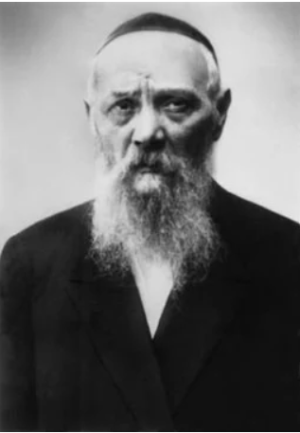

**Rabbi Levi Yitzhak Schneerson**

After the Communist revolution, the authorities demanded that all citizens hand over any gold treasures in their possession to the state. Anyone suspected of hiding gold was imprisoned and tortured in order to reveal the hiding place of the valuables. Many wealthy Jews in the city of Yekaterinoslav tried to conceal their gold and were subsequently imprisoned and tortured.

The city’s Rabbi, Rabbi Levi Yitzchak Schneerson, decided to visit them in prison and rebuke them for endangering their lives and the well-being of their families for the sake of money and gold. Upon entering, he said to them: “If you want to sit in prison — by all means, sit there for keeping Shabbat and fulfilling the Torah and mitzvot. But to be imprisoned and tortured over gold? That is absurd and illogical.” His words convinced many, and as a result, their lives were spared.

*Reprinted from the Parshas Eikev 5785 edition of Living Jewish.*

**The Song of Songs Carpet**

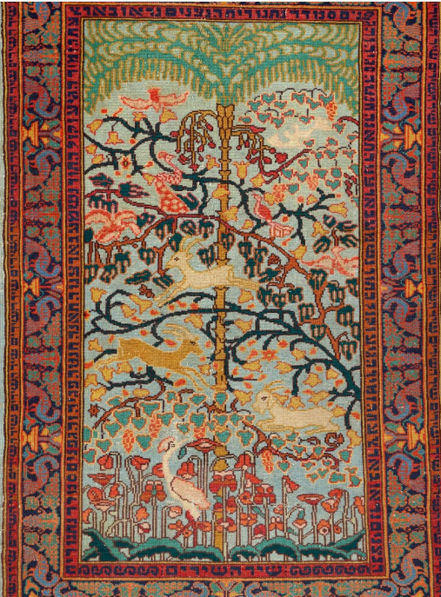

*Reprinted from the 2024 Soetheby’s Judaica Catalogue. The carpet was designed by Aviezer Yaacov Kanterovitch (1890-1961)*